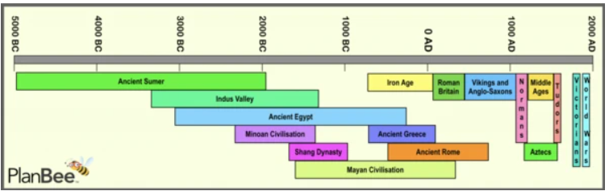
Knowledge Organiser- Year 4 – Spring 1/The Romans – Were the Romans important to Britain?
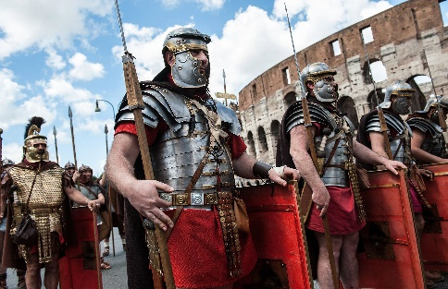
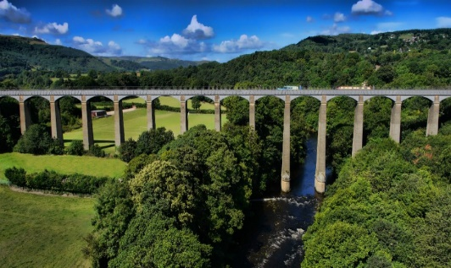

Key Concepts and Facts
1 | The Romans invaded the Celts in Britain | - From around 750BC to 12BC, the Celts were the most powerful people in central and northern Europe.  - It is believed the Romans came to Britain looking for riches – land, slaves and valuable metals such as silver and gold.  - The Romans didn’t just want goods from Britain, they also wanted to invade to show how powerful they were.  - The Britons had been helping the Gauls (French) fight against the Romans. The Romans wanted to punish the Britons for this and make sure that they could no longer do this.
2 | Celtic leaders reacted differently to the Roman invasion | - Boudicca – a Celtic Queen - fought back and eventually lost against the Roman army.  - Cartimandua – a Celtic Queen of a different region- successfully cooperated with the Romans and ruled her kingdom.
3 | The Romans left a great legacy in Britain | The Romans gave us:  - Language. They spoke and wrote in Latin and many of our words are based on Latin words.  - Straight roads. They built them this way so that the army could travel quickly from place to place.  - Hygiene. They built baths and dug wells and built aqueducts to bring clean water to the towns from the hills.  - Roman houses were the first in Britain to be built using concrete and glass, and they were the first to have central heating.  - Christianity was the official Roman religion.
Key Vocabulary
1 | Celts | People living in Britain before the Romans invaded
2 | The Roman Empire | The name used for the land that was controlled by the Romans, including parts of Europe, the Middle East and North Africa.
3 | Archaeology | Archaeology is the study of things that people made, used, and left behind.
4 | Invasion | Invasion is to enter by force to conquer (take over)
5 | Nation | A nation is a group of people who share the same culture, history, language or ethnicity. It can also be described as people living in the same country and government.
6 | Aqueduct | A large system for carrying water from one place to another
7 | Causation | Causation is the action of causing or producing
9 | Emperor | A man who rules an empire.

Key People
1 | Cassius Dio | A Roman historian
2 | Boudica | A Celtic Queen. She was the joint ruler of the British Iceni tribe, who lived in a region of Britain now known as East Anglia
3 | Cartimandua | Queen of the Brigantes, a Celtic tribe of people living in what is now Yorkshire.
4 | Julius Caesar | A famous Roman leader. He won many battles for Rome and helped the Roman Empire grow.

