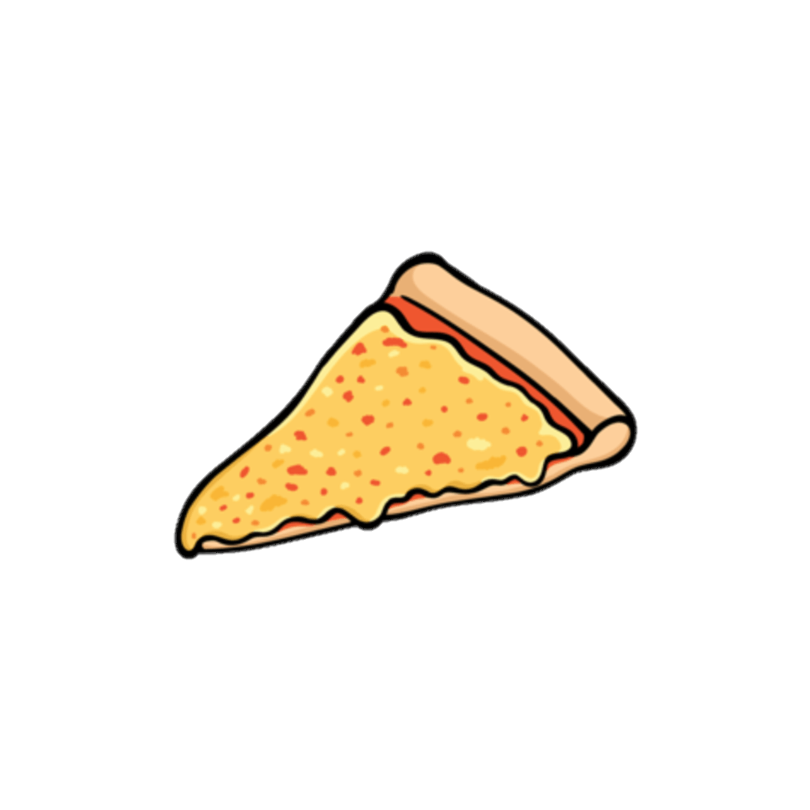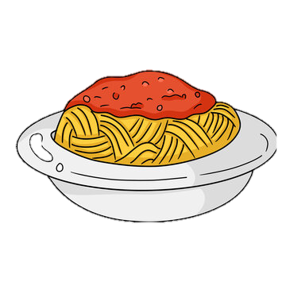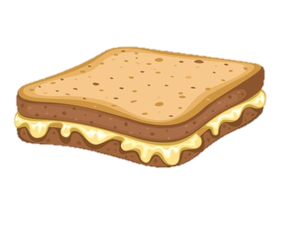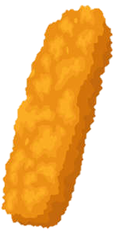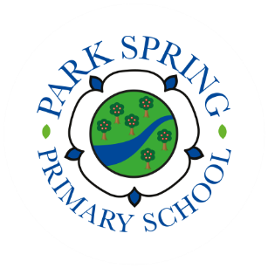

After School Club Menu

**Monday**

Margherita pizza, cucumber sticks and yoghurt

**Tuesday**

Hot dogs, fresh fruit and yoghurt

**Wednesday**

Quorn or fish finger wrap, cucumber sticks and yoghurt

**Thursday**

Pasta and sauce, fresh fruit and yoghurt

**Friday**

Ham or cheese spread sandwich, fresh fruit, cucumber sticks and yoghurt