**Year 1 Geography - Locational Study**

How far have you travelled around the United Kingdom?

1. **United Kingdom – A country made up of England, Wales, Scotland and Northern Ireland**
2. **Capital City – a city where the government works**
3. **The UK is and island surrounded by seas; The North Sea, Irish Sea, Atlantic Ocean and the English Channel**

**Northern Ireland**

**Capital City –** Belfast

**Human and Physical features –** Castles, Titanic Belfast Mountains, hllls, Giant’s Causeway (famous landscape)

**Interesting facts –** It is the smallest country in the UK.

**National Flower -** Shamrock

**Flag**

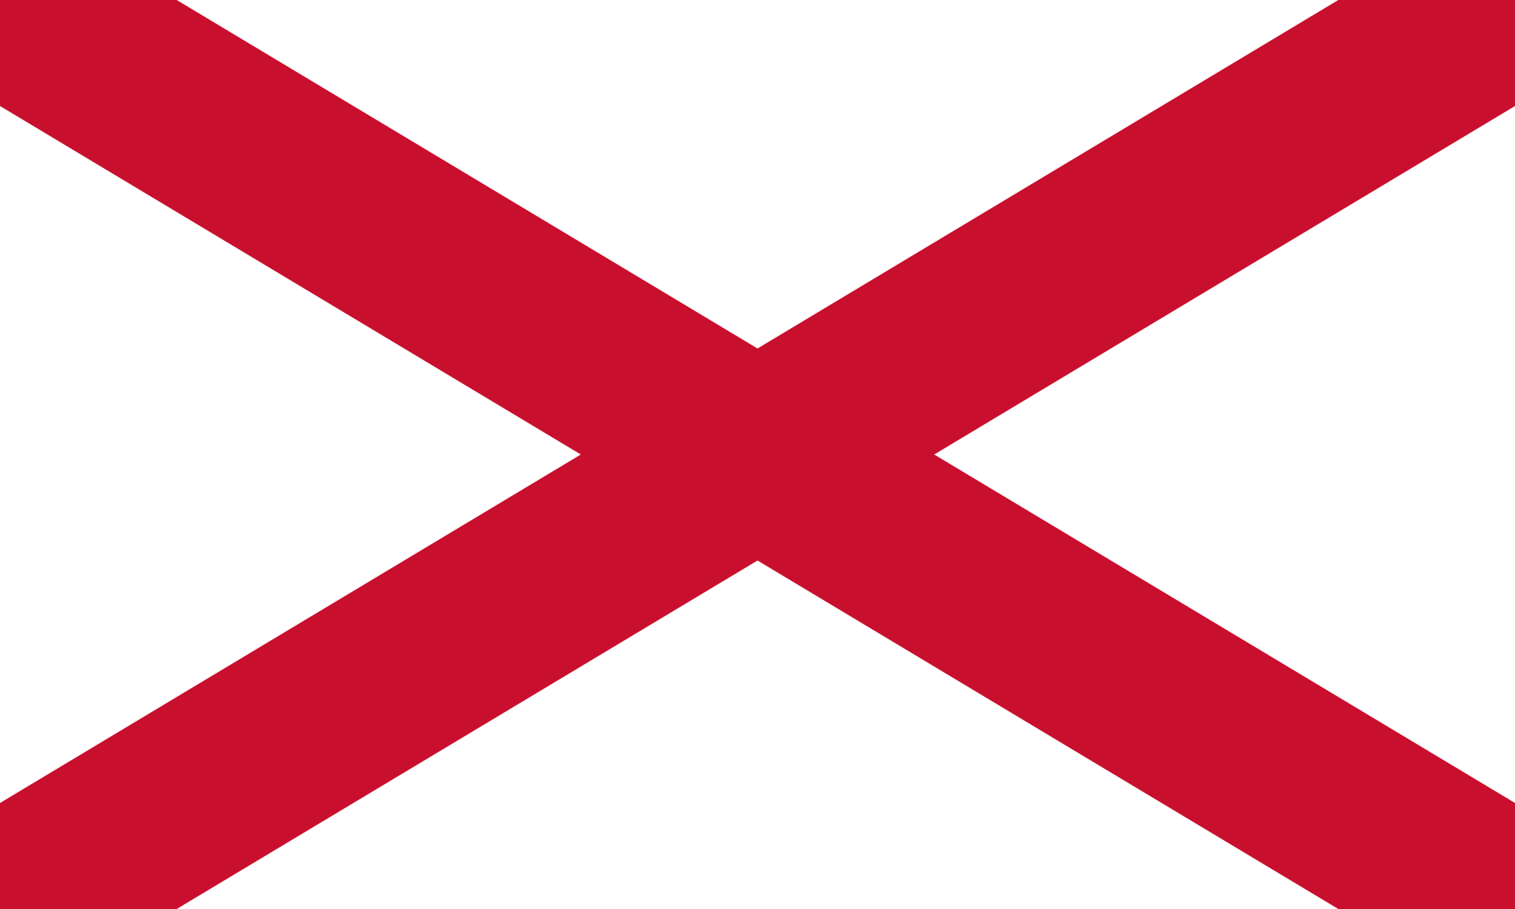

**Wales**

**Capital City –** Cardiff

**Human and Physical features –** Castles and sports stadiumsMountains, hllls and rivers

**Interesting facts –** Wales has its own language.

**National Flower -** Daffodil

**Flag**

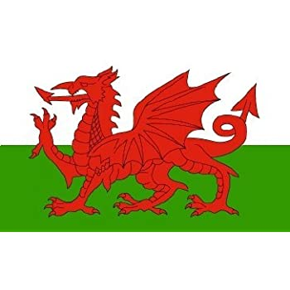

**England**

**Capital City –** London

**Human and Physical features –** Buckingham Palace, Windsor CastleBeaches, countryside and hills

**Interesting facts –** England is the largest country in the UK

It has a royal family

**National Flower -** Rose

**Flag**

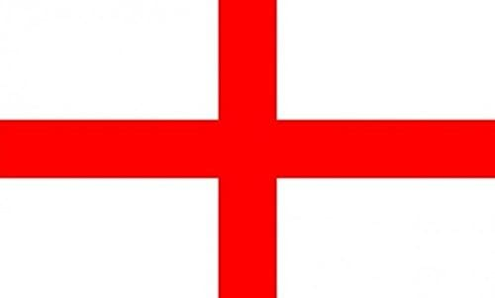

**Scotland**

**Capital City –** Edinburgh

**Human and Physical features –** Edinburgh CastleHills, mountains and lakes (lochs)

**Interesting facts –** Scotland is famous for tartan for family clans, kilts and foods such as haggis.

**National Flower -** Thistle

**Flag**

