Year 3 Cooking Knowledge Organiser
Cucumber raita

Ingredients:
Serves 8

½ cucumber
½ medium onion
125g pot low-fat natural yoghurt
1 x lemon (juice only)
5 mint leaves

Equipment:
Sharp knife
Peeler
Chopping board
Bowl
Juice squeezer
Spoon
Measuring spoons Scissors
Method
1. Wash the cucumber, peel off the skin and chop as finely as possible, using the claw method.
2. Peel and chop the onion as finely as possible, using the claw method.
3. Wash the mint leaves and chop them finely using the scissors.
4. Squeeze the juice from the lemon.
5. Scoop the natural yoghurt into the bowl, mix in 1 x 15ml spoon of lemon juice, chopped cucumber, onion and mint. Stir well.
6. Enjoy with pitta bread, salad or spicy Indian food.

Vocabulary
Peel – to take the skin off a fruit or vegetable.
Raita – a cooling Indian side dish.
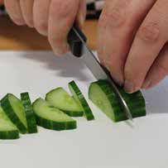 Claw method – making a claw shape with your fingers to hold the food you are cutting. Usually used to cut items into smaller pieces.

Challenge
What quantities of ingredients would you use to make this recipe for 4 people?

