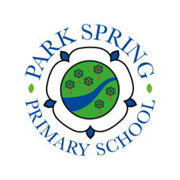
Easter Holidays Bingo KS1

What can you do to keep learning? Let’s achieve together!

 | Examples | Monday | Tuesday | Wednesday | Thursday | Friday
Reading | E.G. Read an eBook, school book, library book, review a book you have read, practise your phonics by saying a sound and thinking of all words with that sound in
Maths | E.G. Practise your number bonds, sing the doubles song, count to 100, count in 10s for as high as you can go, count backwards from 50
Writing | E.G. Write a diary, write your own story (do one part a day) design and label a new toy you could invent, write a fact file about an animal
Your choice | E.G. sing a song, create/do a dance, do some baking, play a board game, do a jigsaw, create an obstacle course/exercise, do some art work (drawing/ collage/ model)

