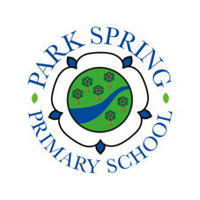
Easter Holidays Bingo EYFS

What can you do to keep learning? Let’s achieve together!

 | Examples | Monday | Tuesday | Wednesday | Thursday | Friday
Reading | E.G. Read an eBook, school book, book from home, practise your phonics by saying a sound and thinking of all words with that sound in, create sounds to go with a story), go on phonics play or ‘Teach your monster to read’, snuggle up and share a story together. Talk about what happens in stories.
Maths  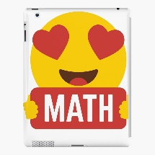 | E.G. Practise counting to 10 or 20, sing number and counting songs, go on a number hunt, count some of your toys, put number cards in order and collect the correct number of objects), sing the shape song. Draw with maths in mind e.g. a spider with 8 legs.
Writing | E.G. Draw a picture and write about it, write a shopping list, practise writing your name in different colours, draw different patterns – bouncy, zig zag, up and down, dots.
Your choice | E.G. sing a song, create/do a dance, do some baking, play a board game, do a jigsaw, create an obstacle course/exercise, do some art work (drawing/ collage/ model), build a den,

