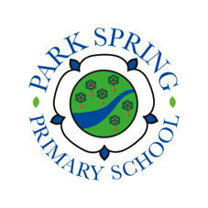
20 books to read in 2020.

Can you read one of each type of book this year? In the box write the title of the book you have read, once completed share it with your teacher.
A book with magic | A book with a main female character | A funny book | A magazine
A book a family member loves | A book with an evil character | A fantasy book | A picture book
A poetry book | A book written before you were born! | A non-fiction book | A book from another country
A book with robots | A Fairy Tale | A book with an animal character | A book about a school
A book by an author who isn’t British | A traditional tale with an alternative story | A book set in the past | A book you would recommend to your teacher
